**EXPERIMENT – 1**

**Aim: -** Installing Vagrant & Creating basic vagrant box using virtual box virtualization.

**Step 1: -**Download and install Oracle Virtual Box 5.x and Vagrant 2.2.7

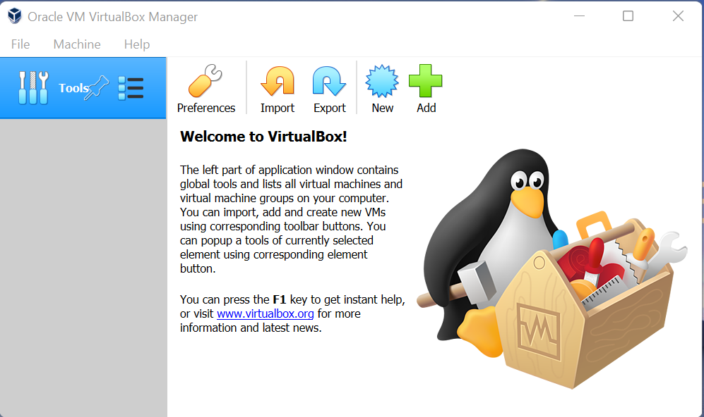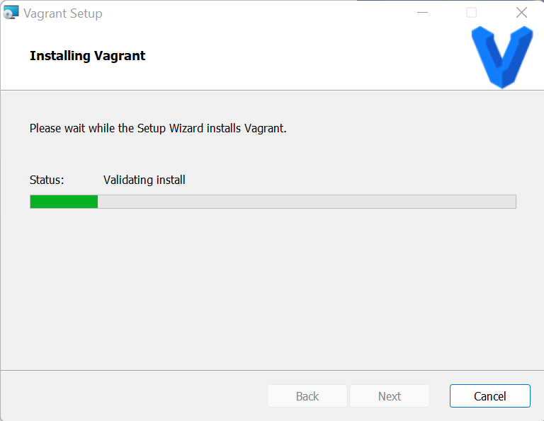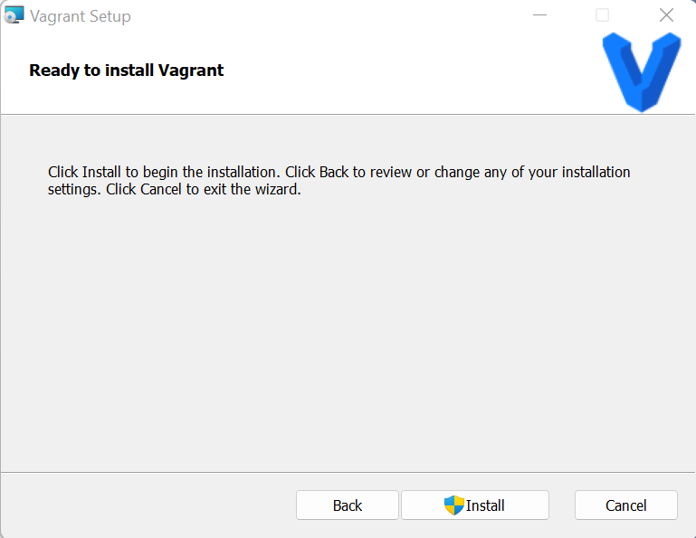

**Step 2: -** Checking version of the Vagrant

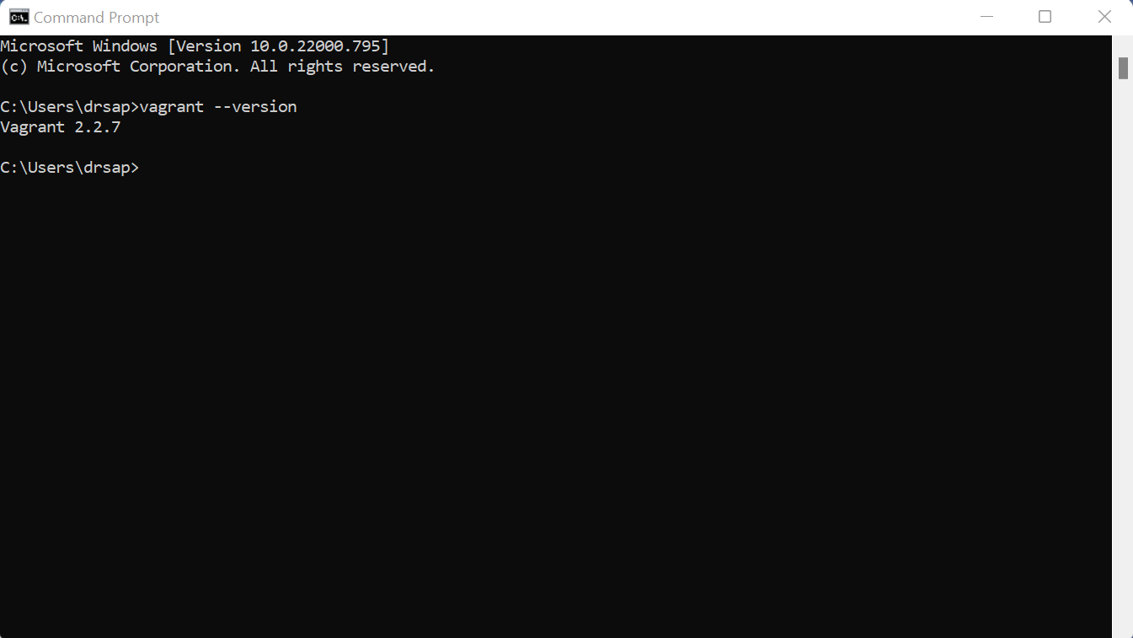

**Step 3: -** Creating a new directory using CMD

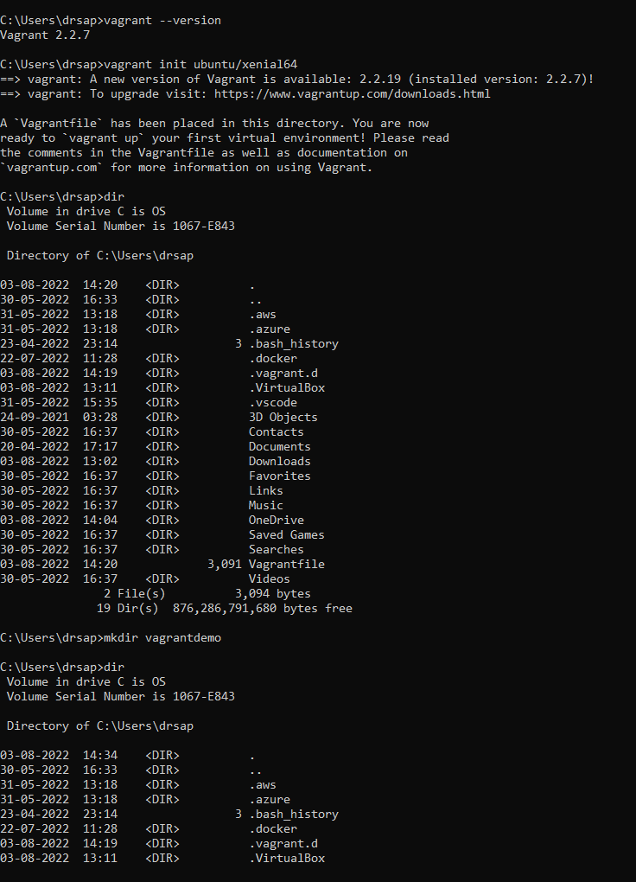

**Step 4: -** Running vagrant init cmd

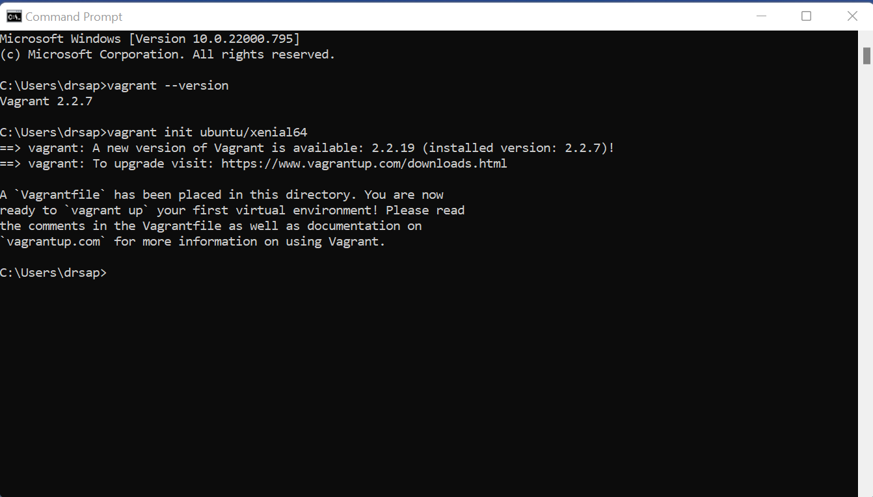

**Step 5: -** Editing Vagrant file and adding ubuntu/xenia64 in box tag

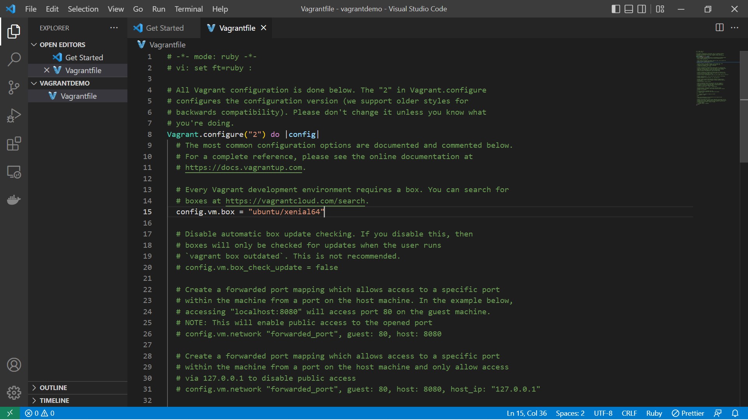

**Step 6: -** Running vagrant up command

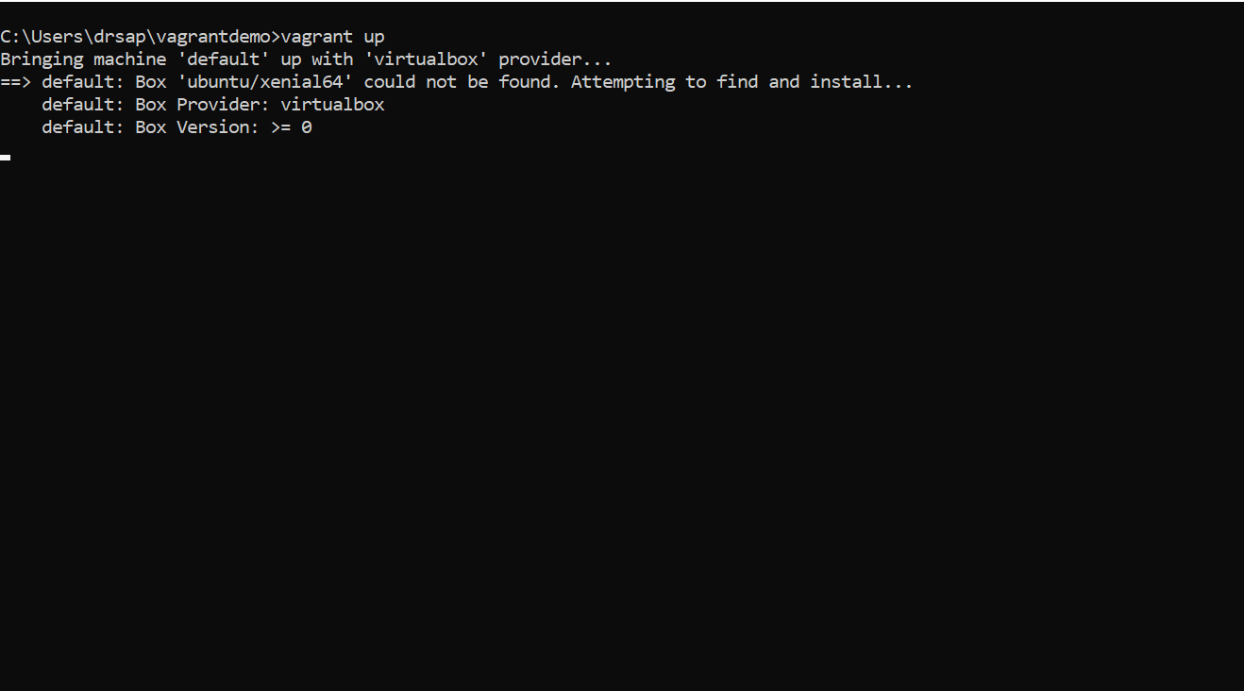

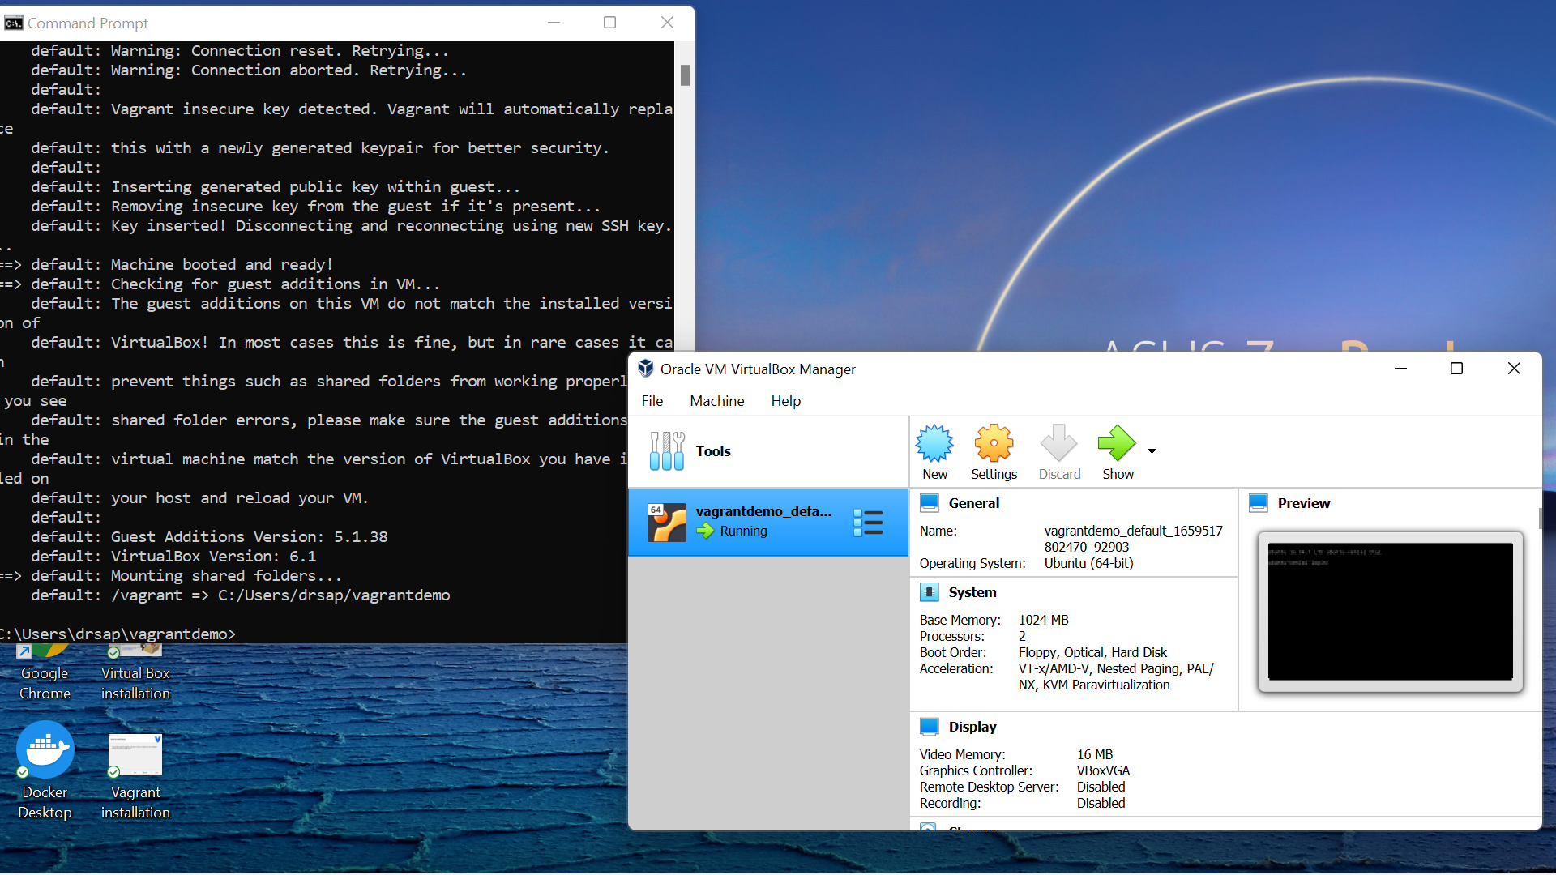

**Step 7: -** Running vagrant SSH command

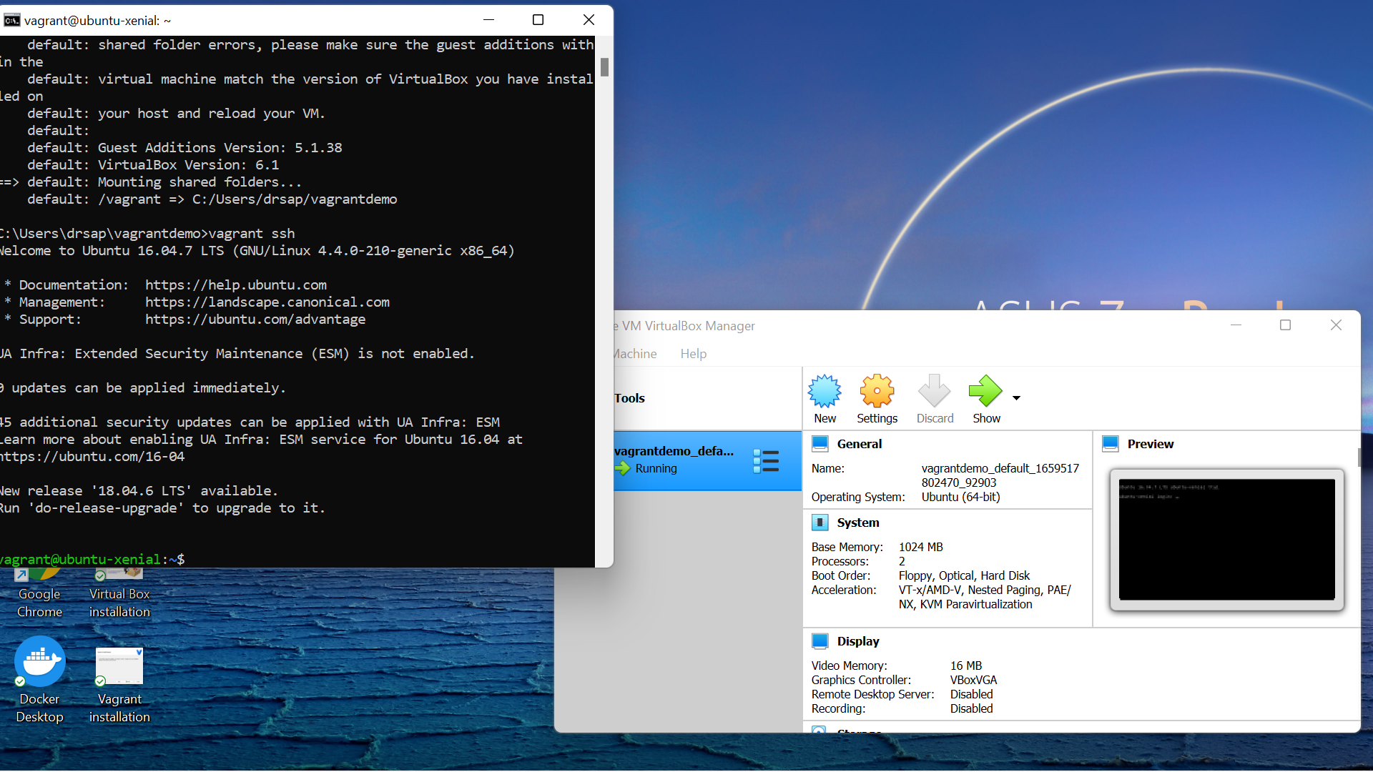

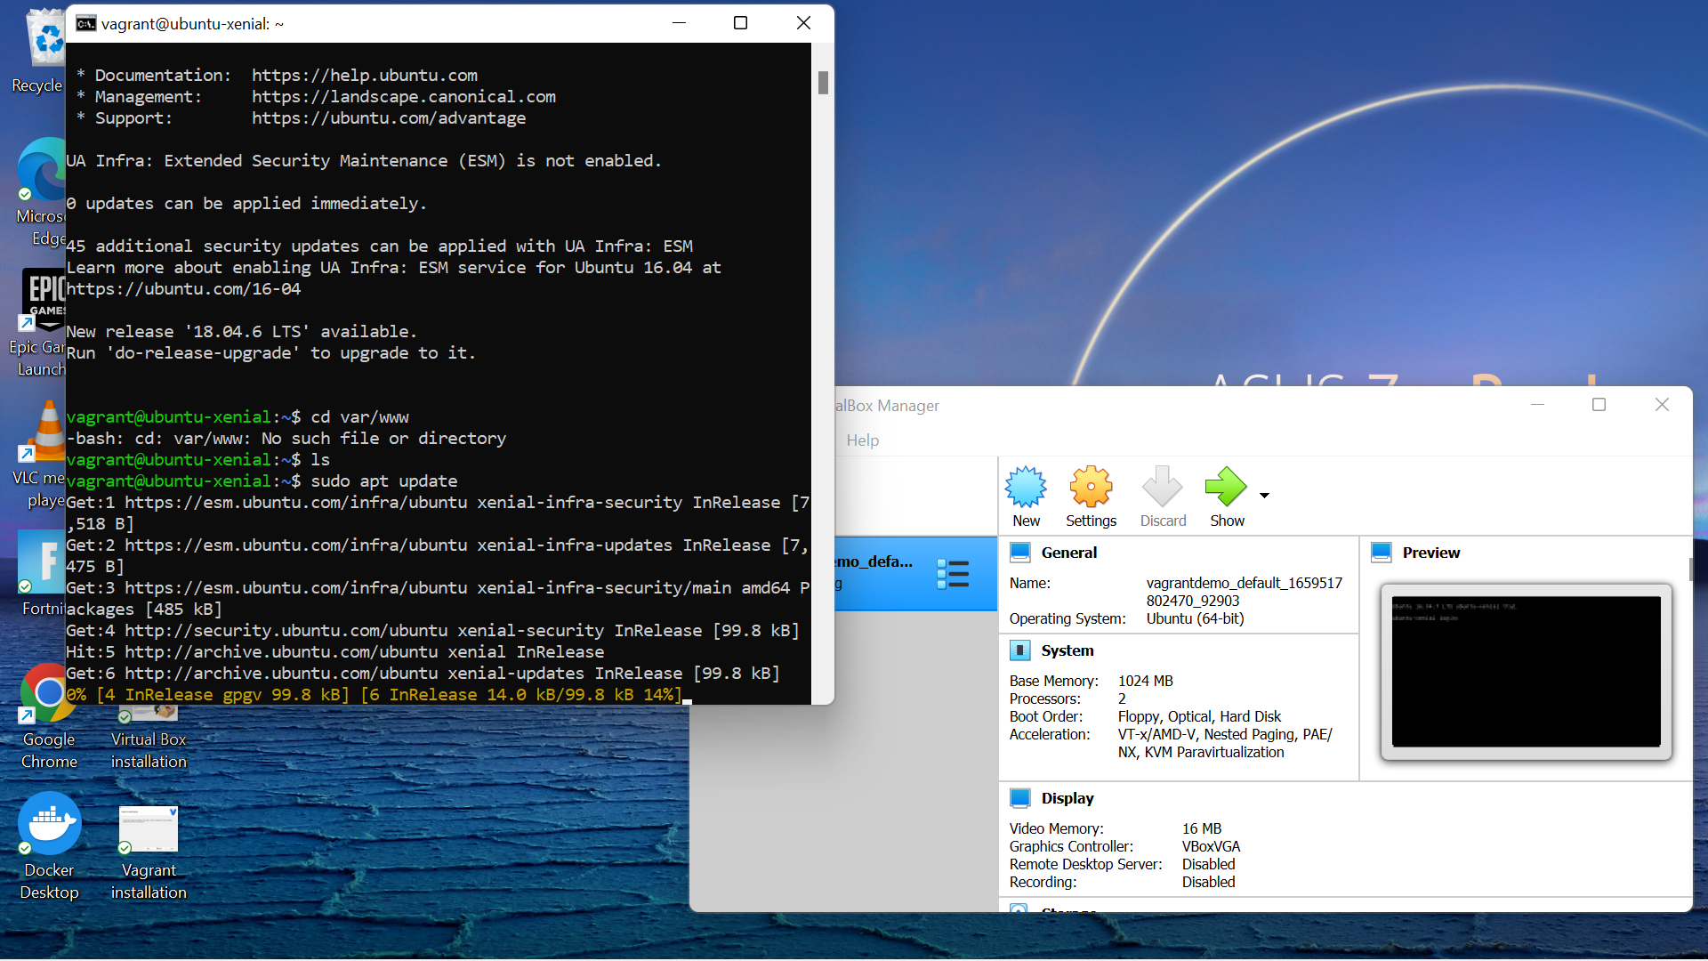

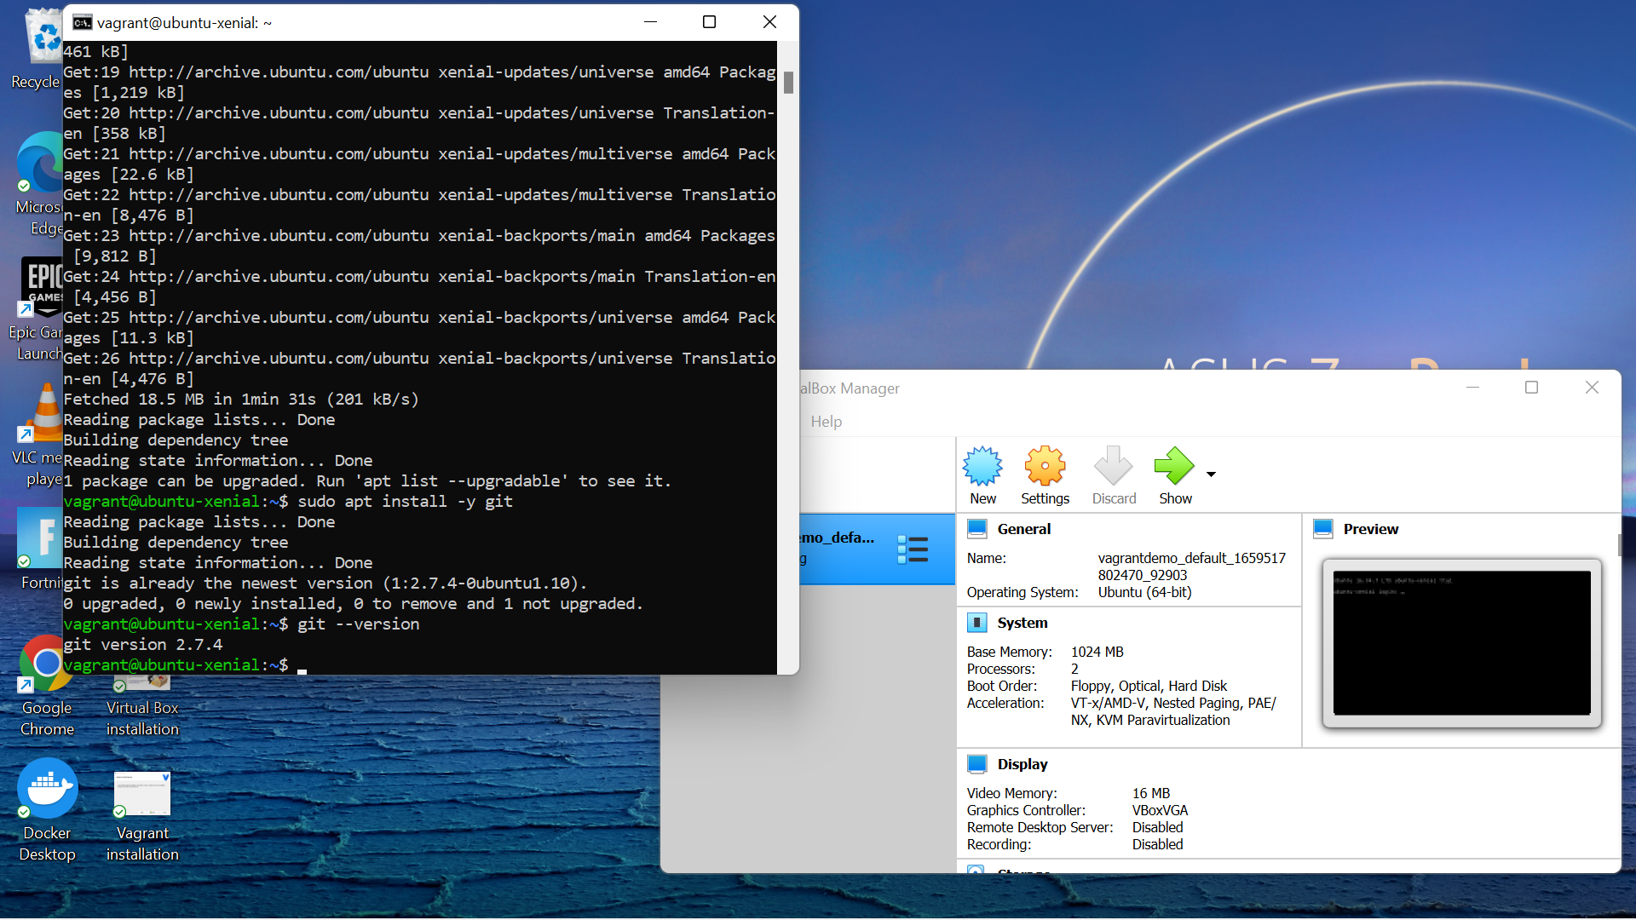

**Step 8: -** Running Vagrant Halt command to stop VM

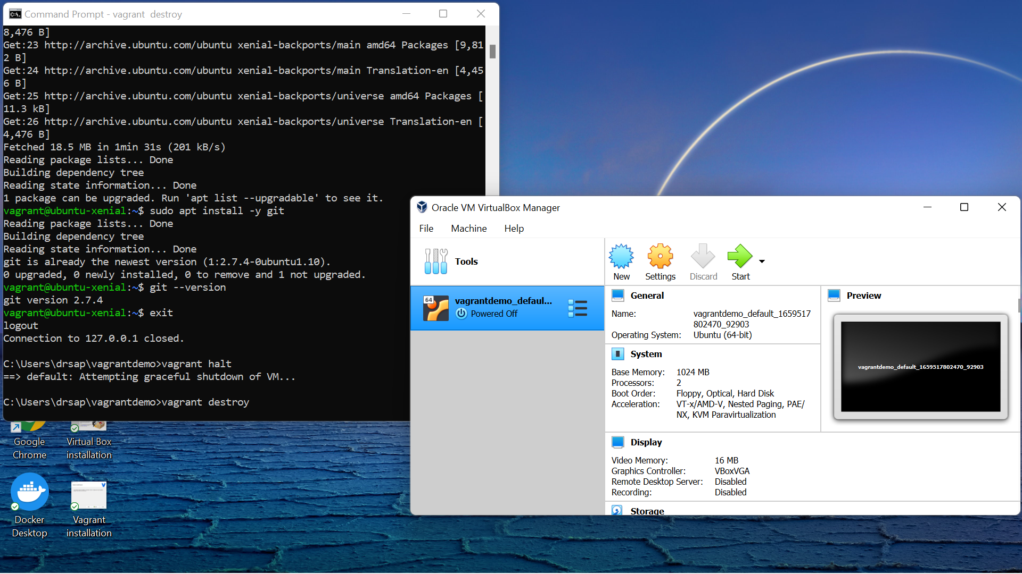

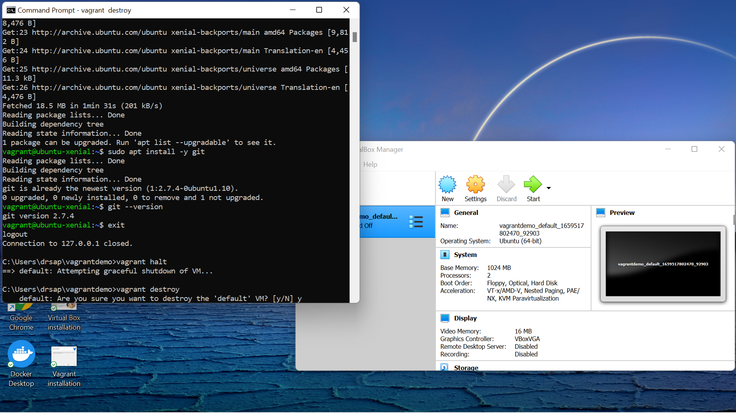

**Step 9: -** Running Vagrant Destroy command to delete VM

